**CSA0683 -DESIGN AND ANALYSIS OF ALGORITHMS**

**(LAB PRACTICAL DAY-1)**

AJAY TANGUTURI

192125078

1. Write a program to Print Fibonacci Series using recursion

**Input:**

#include<stdio.h>

int Fibonacci(int);

int main()

{

int n, i = 0, c;

printf("enter the number:");

scanf("%d",&n);

printf("Fibonacci series\n");

for ( c = 1 ; c <= n ; c++ )

{

printf("%d\n", Fibonacci(i));

i++;

}

return 0;

}

int Fibonacci(int n)

{

if ( n == 0 )

return 0;

else if ( n == 1 )

return 1;

else

return ( Fibonacci(n-1) + Fibonacci(n-2) );

}

**Output:**

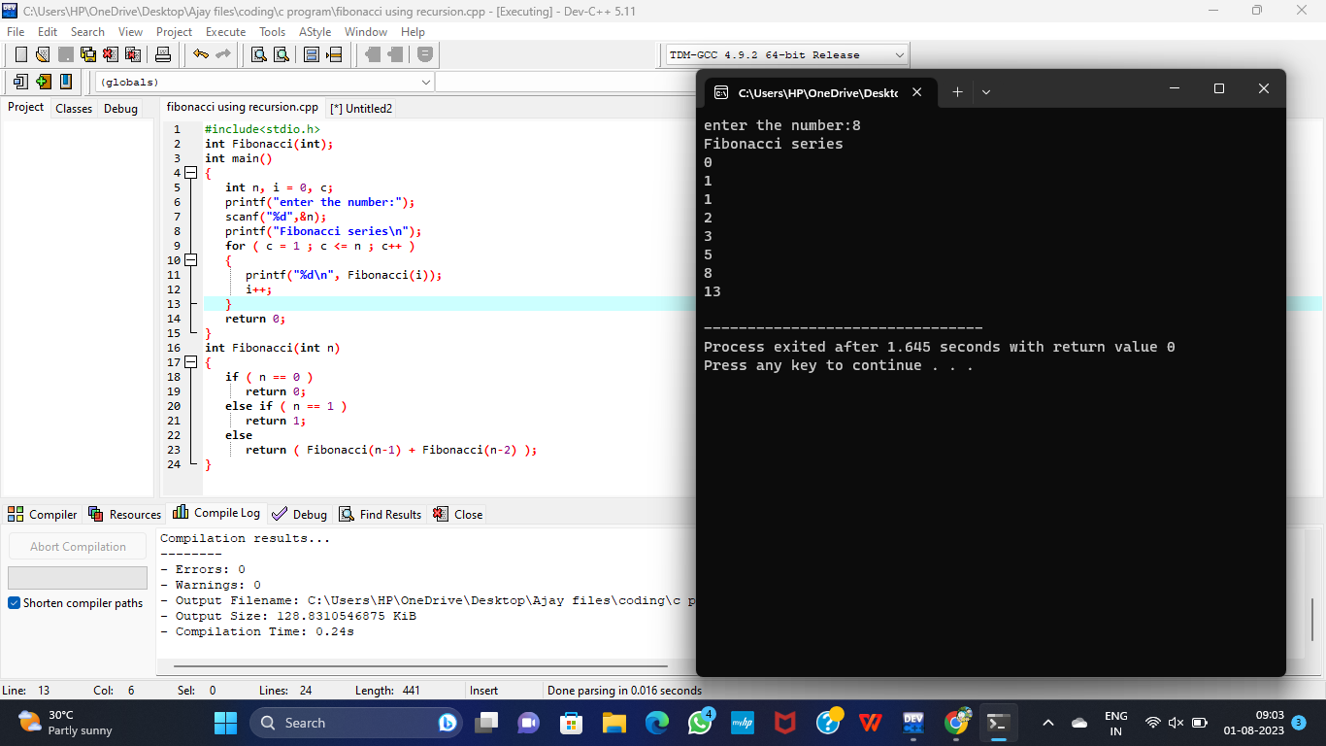

1. Write a program to check the given no is Armstrong or not

**Input:**

#include<stdio.h>

int main()

{

int n,r,sum=0,temp;

printf("enter the number=");

scanf("%d",&n);

temp=n;

while(n>0)

{

r=n%10;

sum=sum+(r*r*r);

n=n/10;

}

if(temp==sum)

printf("armstrong number ");

else

printf("not armstrong number");

return 0;

}

**Output:**

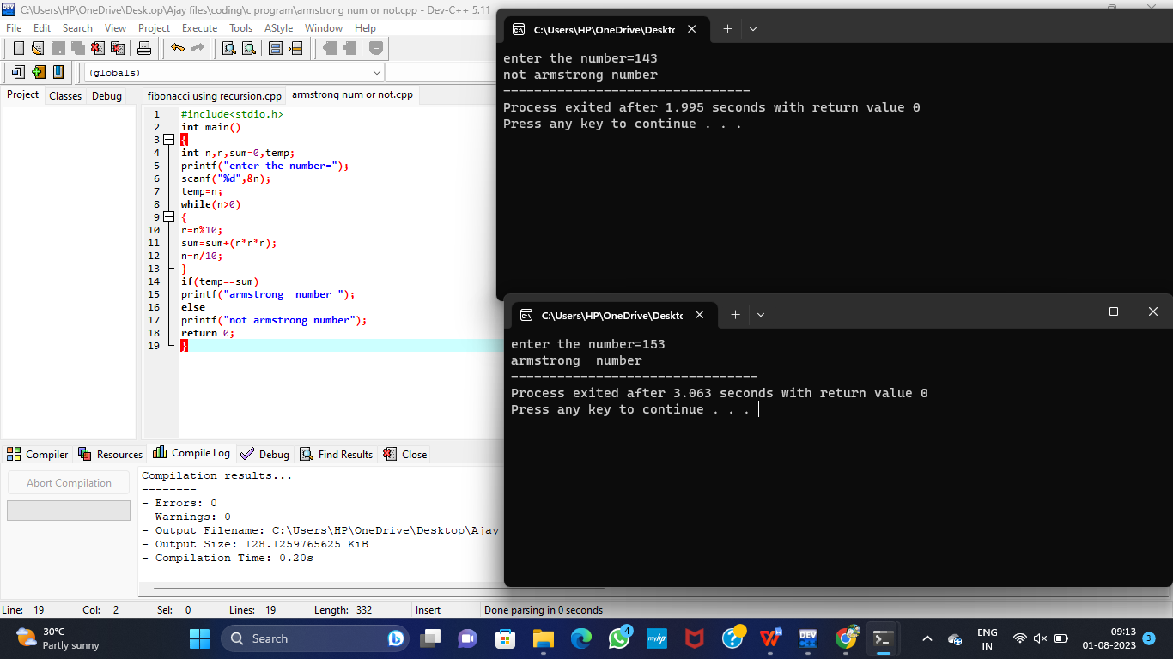

3.Write a program to find the GCD of two numbers .

**Input:**

#include<stdio.h>

int main()

{

int n1,n2,i,gcd;

printf("enter two integers: ");

scanf("%d %d", &n1, &n2);

for(i=1;i <= n1&&i<=n2;++i)

{

if(n1%i==0&&n2%i==0)

gcd = i;

}

printf("gcd of %d and %d is %d",n1,n2,gcd);

return 0;

}

**Output:**

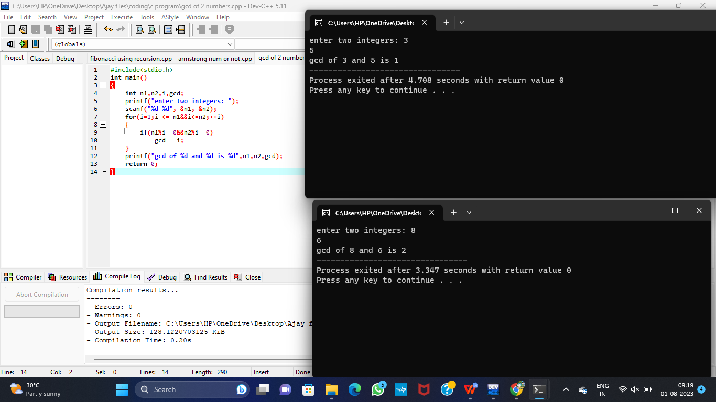

1. Write a program to get the largest element of an array.

**Input:**

#include<stdio.h>

int main(){

int n;

double arr[100];

printf("enter the number of elements (1 to 100): ");

scanf("%d", &n);

for (int i=0;i<n;++i) {

printf("enter number%d: ",i+1);

scanf("%lf",&arr[i]);

}

for (int i=1;i<n;++i) {

if (arr[0]<arr[i]) {

arr[0]=arr[i];

}

}

printf("largest element = %.2lf",arr[0]);

return 0;

}

**Output:**

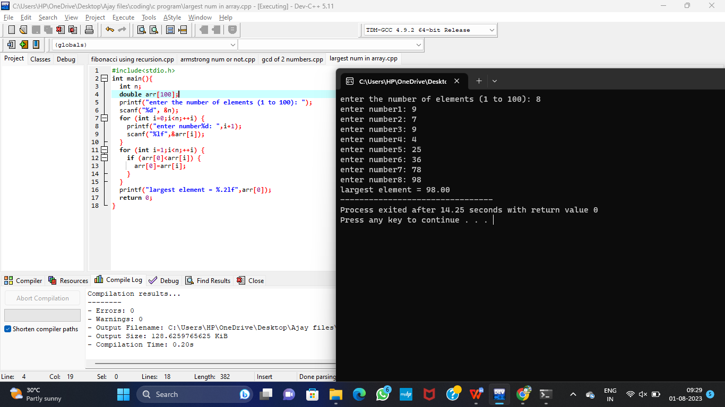

1. Write a program to find the Factorial of a number .

**Input:**

#include<stdio.h>

int main(){

int x,fact=1,n;

printf("enter a num for factorial:");

scanf("%d",&n);

for(x=1;x<=n;x++){

fact=fact*x;

}

printf("factorial of %d is %d",n,fact);

return 0;

}

**Output:**

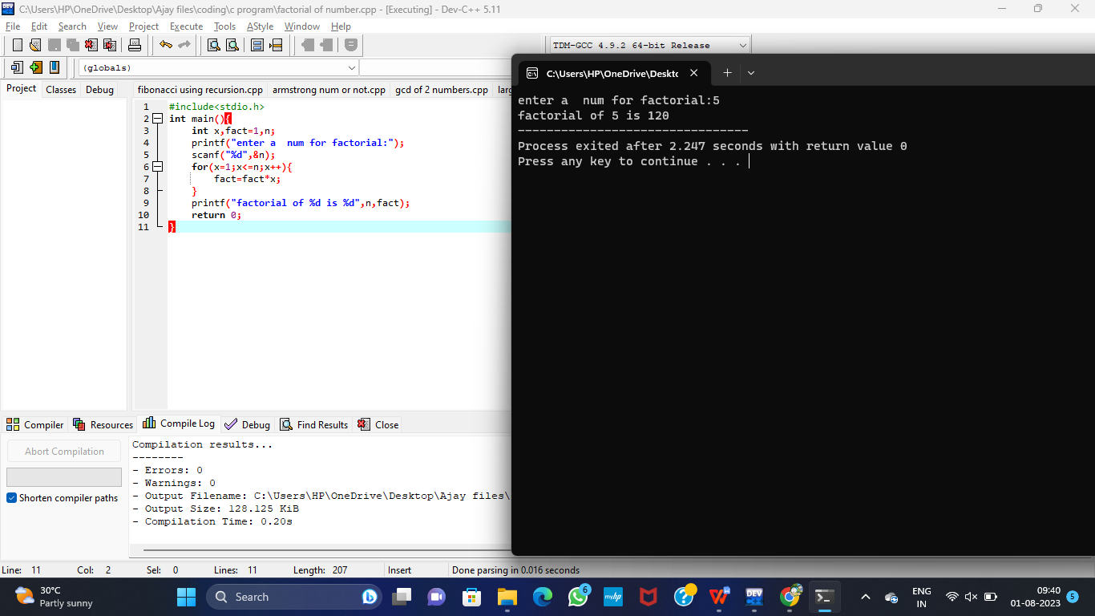

1. Write a program to check a number is a prime number or not .

**Input:**

#include <stdio.h>

int main() {

int n,i,flag = 0;

printf("enter a positive integer: ");

scanf("%d",&n);

if (n==0||n==1)

flag=1;

for(i=2;i<=n/2;++i){

if(n%i==0){

flag=1;

break;

}

}

if(flag==0)

printf("%d is a prime number.",n);

else

printf("%d is not a prime number.",n);

return 0;

}

**Output:**

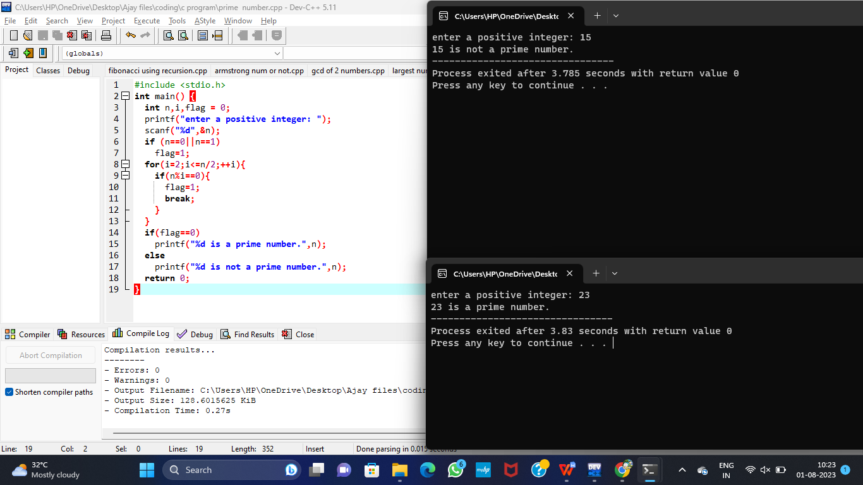

1. Write a program to perform Selection sort

**Input:**

#include <stdio.h>

void swap(int *x, int *y) {

int temp = *x;

*x = *y;

*y = temp;

}

void selectionSort(int arr[], int n) {

int i, j, minIndex;

for (i = 0; i < n - 1; i++) {

minIndex = i;

for (j = i + 1; j < n; j++) {

if (arr[j] < arr[minIndex]) {

minIndex = j;

}

}

swap(&arr[i], &arr[minIndex]);

}

}

void printArray(int arr[], int n) {

for (int i = 0; i < n; i++) {

printf("%d ", arr[i]);

}

printf("\n");

}

int main() {

int n;

printf("Enter the number of elements in the array: ");

scanf("%d", &n);

int arr[n];

printf("Enter the elements of the array:\n");

for (int i = 0; i < n; i++) {

scanf("%d", &arr[i]);

}

printf("Original array: ");

printArray(arr, n);

selectionSort(arr, n);

printf("Sorted array: ");

printArray(arr, n);

return 0;

}

**Output:**

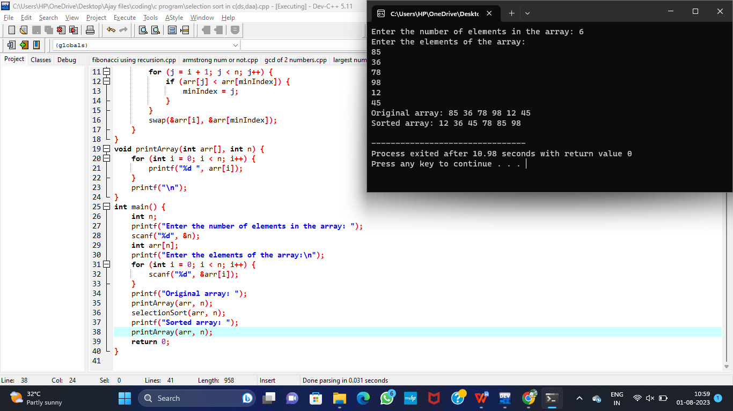

1. Write a program to perform Bubble sort

**Input:**

#include <stdio.h>

void swap(int *x, int *y) {

int temp = *x;

*x = *y;

*y = temp;

}

void selectionSort(int arr[], int n) {

int i, j, minIndex;

for (i = 0; i < n - 1; i++) {

minIndex = i;

for (j = i + 1; j < n; j++) {

if (arr[j] < arr[minIndex]) {

minIndex = j;

}

}

swap(&arr[i], &arr[minIndex]);

}

}

void printArray(int arr[], int n) {

for (int i = 0; i < n; i++) {

printf("%d ", arr[i]);

}

printf("\n");

}

int main() {

int n;

printf("Enter the number of elements in the array: ");

scanf("%d", &n);

int arr[n];

printf("Enter the elements of the array:\n");

for (int i = 0; i < n; i++) {

scanf("%d", &arr[i]);

}

printf("Original array: ");

printArray(arr, n);

selectionSort(arr, n);

printf("Sorted array: ");

printArray(arr, n);

return 0;

}

**Output:**

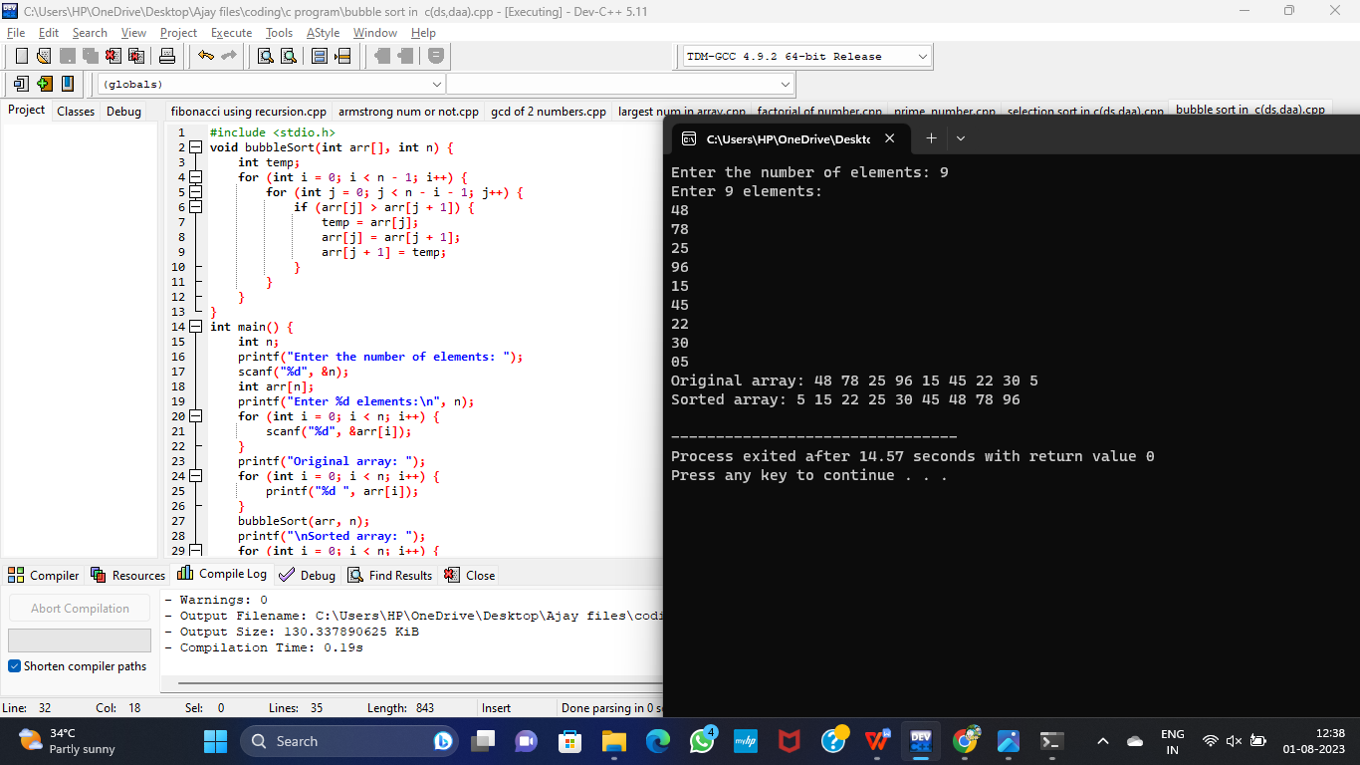

1. Write a program for to multiply two Matrix

**Input:**

#include<stdio.h>

#include<stdlib.h>

int main(){

int a[10][10],b[10][10],mul[10][10],r,c,i,j,k;

system("cls");

printf("enter the number of row:");

scanf("%d",&r);

printf("enter the number of column:");

scanf("%d",&c);

printf("enter the first matrix element:\n");

for(i=0;i<r;i++)

{

for(j=0;j<c;j++)

{

scanf("%d",&a[i][j]);

}

}

printf("enter the second matrix element:\n");

for(i=0;i<r;i++)

{

for(j=0;j<c;j++)

{

scanf("%d",&b[i][j]);

}

}

printf("multiply of the matrix:\n");

for(i=0;i<r;i++)

{

for(j=0;j<c;j++)

{

mul[i][j]=0;

for(k=0;k<c;k++)

{

mul[i][j]+=a[i][k]*b[k][j];

}

}

}

for(i=0;i<r;i++)

{

for(j=0;j<c;j++)

{

printf("%d\t",mul[i][j]);

}

printf("\n");

}

return 0;

}

**Output:**

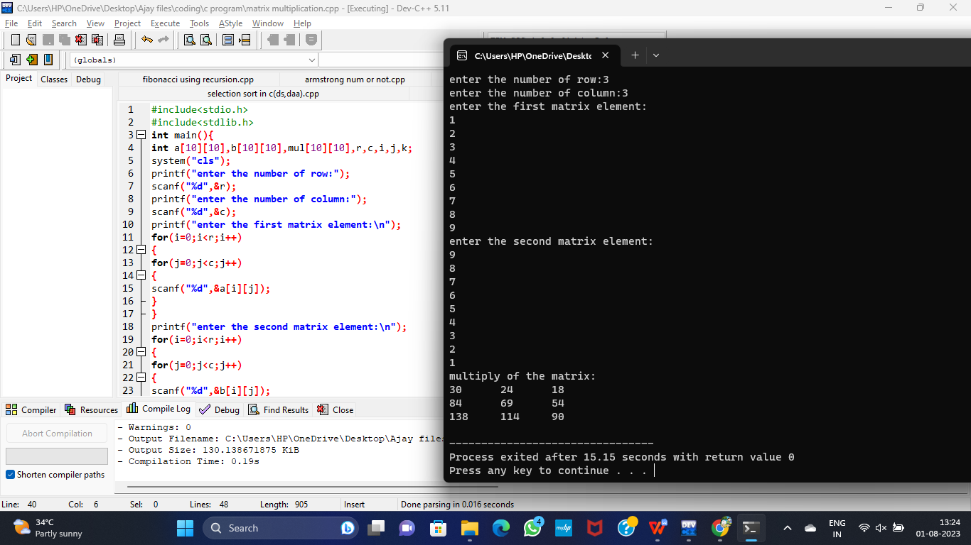

1. Write a program for to check whether a given String is Palindrome or not

**Input:**

#include<stdio.h>

int main()

{

int n,r,sum=0,temp;

printf("enter the number/string:");

scanf("%d",&n);

temp=n;

while(n>0)

{

r=n%10;

sum=(sum*10)+r;

n=n/10;

}

if(temp==sum)

printf("palindrome");

else

printf("not palindrome");

return 0;

}

**Output:**

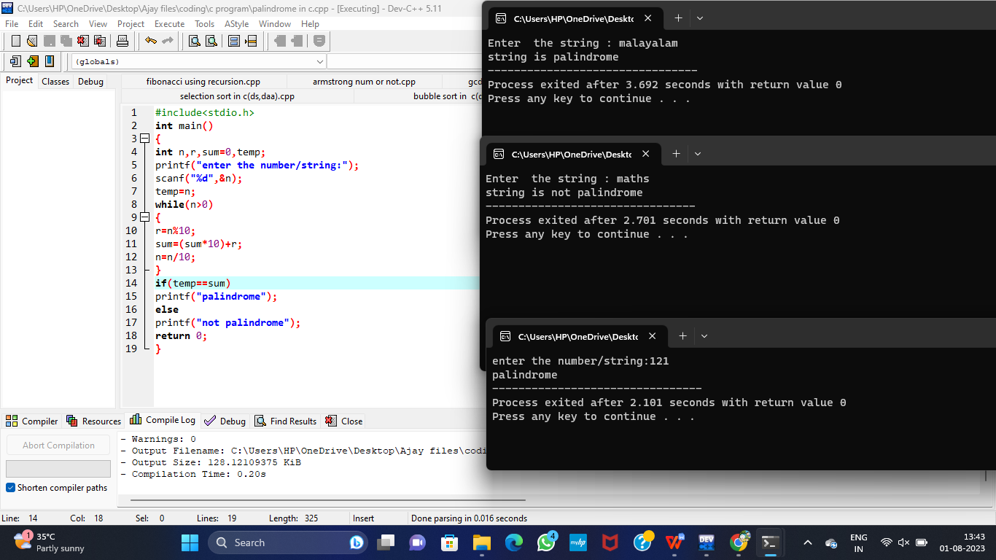

1. Write a program for to copy one string to another

**Input:**

#include<stdio.h>

#include<conio.h>

#include<string.h>

int main()

{

char str1[20], str2[20];

printf("Enter the string: ");

gets(str1);

printf("\nString 1 = %s", str1);

strcpy(str2, str1);

printf("\nString 2 = %s", str2);

getch();

return 0;

}

**Output:**

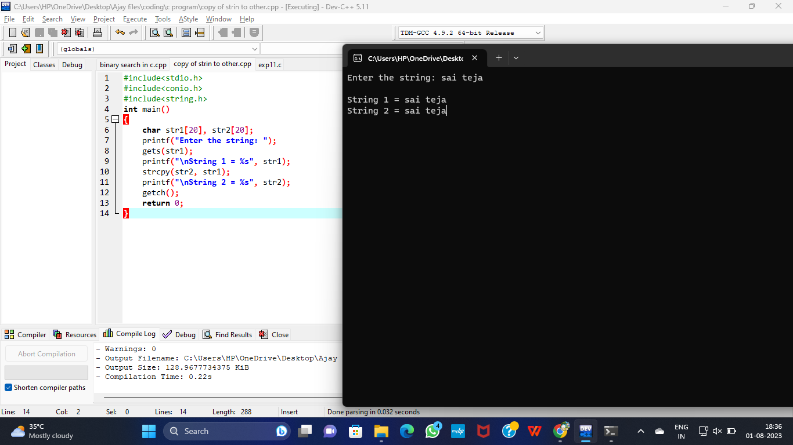

1. Write a Program to perform binary search.

**Input:**

#include<stdio.h>

int binarySearch(int arr[],int left,int right,int target) {

while(left<=right){

int mid=left+(right-left)/2;

if(arr[mid]==target){

return mid;

}else if(arr[mid]<target){

left=mid+1;

}else{

right=mid-1;

}

}

return -1;

}

int main(){

int n,target;

printf("enter the number of elements in the array: ");

scanf("%d",&n);

int arr[n];

printf("enter the sorted elements of the array:\n");

for(int i=0;i<n;i++){

scanf("%d",&arr[i]);

}

printf("enter the element to be searched: ");

scanf("%d",&target);

int result=binarySearch(arr,0,n-1,target);

if(result!=-1){

printf("element found at index %d.\n",result);

}else{

printf("element not found in the array.\n");

}

return 0;

}

**Output:**

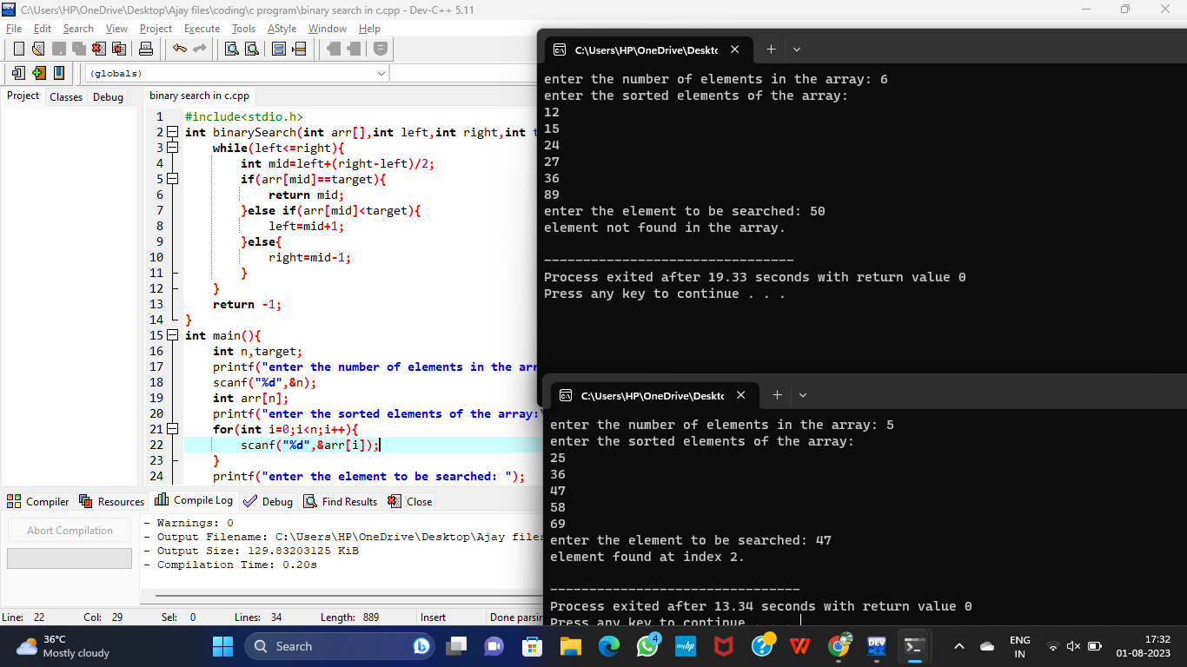

1. Write a program to print the reverse of a string

**Input:**

#include<stdio.h>

#include<string.h>

int main()

{

char str[40];

printf("\nenter a string to be reversed: ");

scanf("%s",str);

printf("\n after the reverse of a string: %s ",strrev(str));

return 0;

}

**Output:**

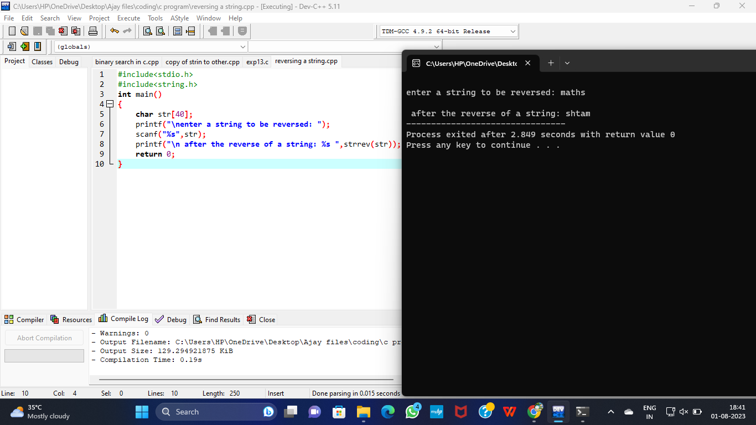

14.Write a program to find the length of a string.

**Input:**

#include <stdio.h>

#include <string.h>

int main()

{

char Str[1000];

int i;

printf("Enter the String: ");

scanf("%s",Str);

for (i = 0;Str[i]!='\0';++i);

printf("Length of Str is %d",i);

return 0;

}

**Output:**

